Module Title
Sampling I

Time Management
The expected time to deliver this module is 50 minutes. 20 minutes are reserved for team practices and exercises and 30 minutes for lecture.

Overview/motivation/topical background
This module is designed to teach the student about the concept random number and its application to sampling through practical examples and team exercises. This lecture is also designed to make the students reflect actively about the practical problems involved in sampling.

Learning Objectives
After this class the students should be able to understanding concepts of the basic terminology of sampling, the mean of Random Number and its application to sampling.

After this class the students should be able to understanding the mean of Random Number and its application to Sampling.

Materials
PowerPoint software and a computer screen projector

Prerequisite knowledge for the students
The student will be required to have little previous knowledge about Conditional Probability and Probability Distributions.

Preparation requirements for the instructor

The instructor will want to familiarize himself/herself with the chapter 1of book “Statistics: Concepts and Controversies” of David S. Moore, and the power point presentation.

Hints, tips, and traps for the instructor
The instructor should be certain to keep the time constraints provided for all exercises and must be able to deal with teams.

Reference materials

“Statistics: Concepts and Controversies” of David S. Moore (W. H. Freeman and Company, 2001)

Classroom resources/computer usage
To deliver this module properly, it is necessary to have a computer with PowerPoint and a screen projector.
Suggested homework for this module
Exercise 1-4 (chapter 1, p.36)

Sampling

"You don't have to eat the whole ox to know that the meat is tough."

(Samuel Johnson)

Introduction
The essential idea of sampling is to gain information about the whole by examining only a part.

The basic terminology used by statisticians to discuss sampling:

- Population - the entire group of objects about which information is wanted.

- Unit - any individual member of the population.

- Sample - part or subset of the population used to gain information about the whole.

- Sampling Frame - the list of units from which the sample is chosen.

- Variables - characteristic of a unit, to be measured for those units in the sample.

Population is defined in terms of our desire for information. If we desire information about all U.S. college students that is our population even if students at only one college are available for sampling. It is important to define clearly the population of interest. If you seek to discover what fraction of the American people favor a ban on private ownership of handguns, you must specify the population exactly. Are all U.S. residents included in the population, or only citizens? What minimum age will you insist on? In a similar sense, when you read a pre - election poll, you should ask what the population was: all adults, registered voters only, Democrats or Republicans only. The distinction between population and sample is basic to statistics. Some examples will illustrate this distinction and introduce some major uses sampling. These brief descriptions also indicate the variables to be measured for each unit in the sample. They do not state the sampling frame. Ideally, sampling frame should be a list of all units in the population. But, as we shall obtaining such a fist is one of the practical difficulties in sampling.

Example: Acceptance sampling is the selection and careful inspection of a sample from a large lot of a product shipped by a supplier. On the basis of this, a decision is made whether to accept or reject the entire lot. The exact acceptance sampling procedure to be followed is usually stated in the contract between the purchaser and the supplier.

Population | Sample
A lot of items shipped by the supplier | A portion of the lot that the purchaser chooses for inspection

Sampling of accounting data is a widely accepted accounting procedure, as well as in Control of manufacture process. It is quite expensive and time consuming to verify each of a large number of invoices, accounts receivable, spare parts in inventory, and so forth. Accountants therefore use a sample of invoices or accounts receivable in auditing a firm's records, and the firm itself counts its inventory of spare parts by taking a sample of it.

Important observations about Sampling

- Why sampling? The first reason should be clear from the examples we have given: If the population is large, it is too expensive and time - consuming to take information about its units.

Even the federal government, which can afford a census, uses samples to collect data on prices, employment, and many other variables. Attempting to take a census would result in this month’s employment rate being available next year rather than next month.

- Some way of sampling could be not representative of the population and lead to misleading conclusions about the population

So sample we must. Selecting a sample from the units available often simple enough, but this simplicity is misleading. If I were a supplier of orange who sold your company several crates per week, you would be wise to examine a sample of oranges in each crate to determine the quality of the oranges supplied. You find it convenient to inspect a few oranges from the top the each crate. But these oranges may not be representative of the entire crate if, for example, those on the bottom are damaged more often in shipment. Your method of sampling might even tempt me to be sure that the rotten orange are packed on the bottom with some good ones on top for you to inspect.

- When a sampling method produces results that consistently and repeatedly differ from the truth about the population in the same direction, we say that the sampling method is biased.

Suppose that we obtain a sample of public opinion by hiring interviewers and sending them to street corners and shop centers to interview the public. The typical interviewer is a white middle-class female. She is supposed to interview unlikely many working-class males, blacks, or others who are unlike her. Even if we assign the interviewer quotas by race, age, sex, she will tend to select the best-dressed and least threatening member each group. The result will be a sample that systematically over-represents some parts of the population (persons of middle - class appearance) and under-represents others. The opinions of such a convenience sample may be very different from those of the population as a whole.

Simple Random Sampling (SRS)

A remedy for the "favoritism" usually caused by a convenience sample is to take a simple random sample. The essential idea is to give each unit in the sampling frame the same chance to be chosen for the sample as any other unit. For reasons to be explained later, the precise definition is slightly more complicated. Here it is.

A simple random sample of size n is a sample of n units chosen in such a way that every collection of n units from the sampling frame has the same chance of being chosen.

One way is to use physical mixing: Identify each unit in the sampling frame on an identical tag, mix the tags thoroughly in a box, and then draw one blindly. If the mixing is truly complete, every tag in the box has the same chance of being chosen. The unit identified on the tag drawn is the first unit in our simple random sample (SRS). Now draw another tag without replacing the first. Again, if the mixing is thorough, every remaining tag has the same chance of being drawn. So every pair of tags has the same chance of being the pair we have now drawn; we have a SRS of size 2. To obtain a SRS of size n, we continue drawing until we have n tags corresponding to n units in the sampling frame. Those n units are a SRS of size n.

Physical mixing is even practiced on some occasions. But it is surprisingly difficult to achieve a really thorough mixing, as those who spend their evenings shuffling cards know. Physical mixing is also awkward, time-consuming, and some time impossible to carry out. There are several way obtain a SRS. David Moore presents one very didactical and well known way to obtain a SRS and understand the concept of random sample.

Picture a wheel (such as a roulette wheel) rotating on a smooth bearing so it does not favor any particular orientation when coming to rest. Divide the circumference of the wheel into ten equal sectors and label them 0, 1, 2, 3, 4, 5, 6, 7, 8, 9. Fix a stationary pointer at the wheel's rim and spin the wheel. Slowly and smoothly it comes to rest. Sector number 2 (say) is opposite the pointer.

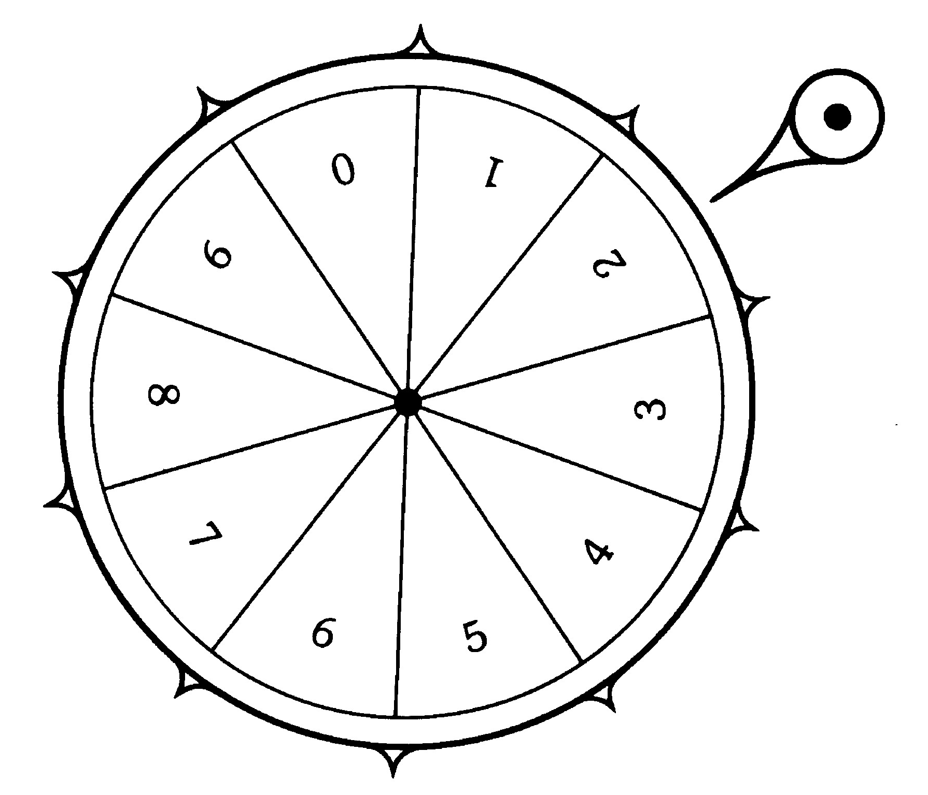

Spin the wheel again. It comes to rest with (say) sector number 9 opposite the pointer. If we continue this process, we will produce a string of the digits 0, 1, . . ., 9 in some order. On any one spin, the wheel has the same chance of producing each of these ten digits. And because the wheel has no memory, the outcome of any one spin has no effect on the outcome of any other. We are producing a table of random digits.

A table of random digits is a list of the ten digits 0, 1, 2, 3, 4, 5, 6, 7, 8, 9 having the following properties:

- The digit in any position in the list has the same chance of being any one of 0, 1, 2, 3, 4, 5, 6, 7, 8, 9.
- The digits in different positions are independent in the sense that the value of one has no influence on the value of any other.

To use the table, we need the following facts about random digits, which are consequences of the basic properties 1 and 2.

- Any pair of digits in the table has the same chance of being any of the 100 possible pairs 00, 01, 02, …, 98, 99.
- Any triple of digits in the table has the same chance of being any of the 1000 possible triples 000, 001, 002, . . ., 998, 999.
- And so on for groups of four or more digits from the table.

How to use Table A to choose a SRS is best illustrated by a sequence of examples.

Example:. A dairy products manufacturer must select a SRS of size 5 from 100 lots of yogurt to check for bacterial contamination. We proceed as follows.

- Label the 100 lots 00, 01, 02,…, 99 in any order.

- Enter Table A in any place and read systematically through it. We choose to enter line 111 and read across:

81486 69487 60513 09297

- (c) Read groups of two digits. Each group chooses a label attached to a lot of yogurt. Our SRS consists of the lots having labels

81, 48, 66, 94, 87.

Exercise

Supposing a process that produces 500 parts during the day, propose some practical and simple (economical) ways for sampling the daily bath for quality controlling.

The teams have 10 minutes to elaborate a list of 3 alternatives ways;

5 minutes to present to the class 5 to discuss

Generating RN by software

SPSS;

Arena;

Promodel;

Excel; …

Excel function RAND

Returns an evenly distributed random number greater than or equal to 0 and less than 1.

Syntax: RAND( )

To generate a random real number between a and b, use: RAND()*(b - a) + a

Further questions

How to test if a sampling method is good or not?

How to test a sample?

How many elements in a sample is enough?

Reference

“Statistics: Concepts and Controversies”

David S. Moore

W. H. Freeman and Company

1979

