Case Study #1 -- Value Stream Mapping

This Case Study presents the manufacture of 3 products in a product family. The products are shown in Figures 1-3. The parts are used to organize key rings, and as can be seen come in various styles. Raw materials for the key ring holder are:

Bill of Material

Item Description Qty

1 Wooden base 5.25 X 5.25 X 0.875 pine 1

2 0.25 inch X 1.00” pine dowels Per drawing

Process Plan – 121-2 Dowel pins

Op # Description Time (You measure/estimate)

- Retrieve material (1/4 X 36” dowels)
- Mark length
- Saw pin
- Visually inspect

Process Plan – 121-1a Drill holes in base

Op # Description Time (You measure/estimate)

- Retrieve material (5.25 X 5.25 X .875 pine stock)
- Mark hole centers
- Punch holes
- Drill holes

Process Plan – 121-A Assemble components

Op # Description Time (You measure/estimate)

- Retrieve base 121-1a
- Retrieve dowel piece
- Insert dowel into hole
- Press/hammer into position
- Repeat until complete

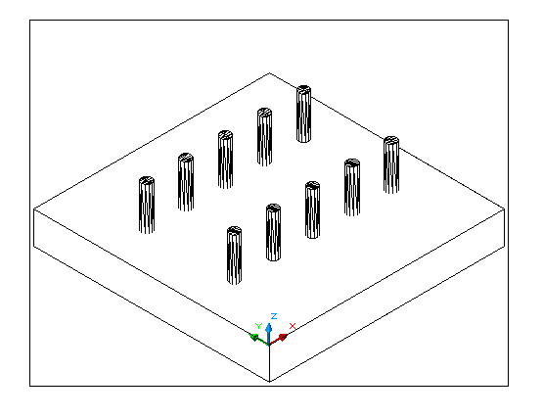 Figure 1. Rectangular key ring holder

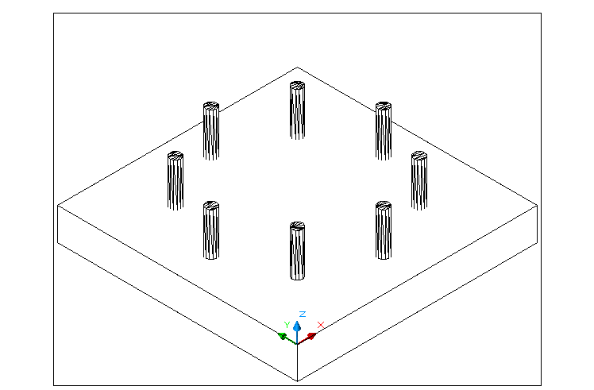 Figure 2. Circular key ring holder

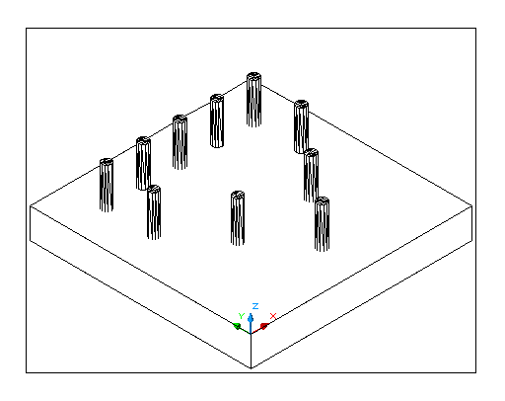 Figure 3 Triangular key ring holder

Rectangular key ring holder

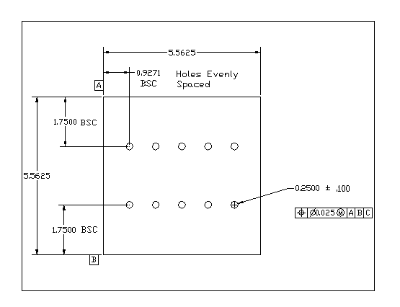
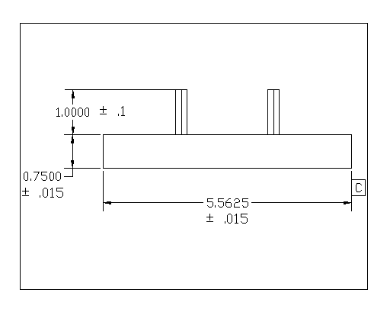
Circular key ring holder
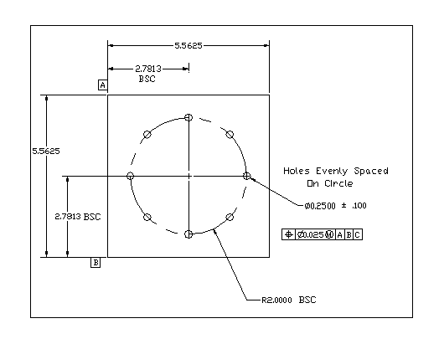
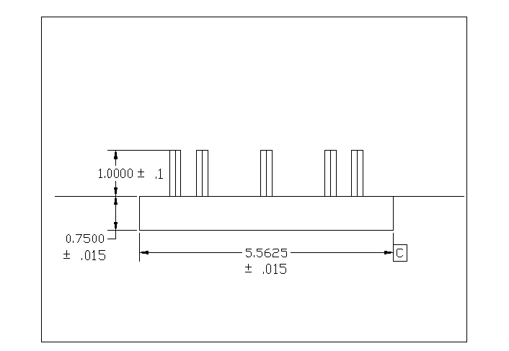

Triangular key ring holder
