Zap Electronics
What-If Analysis for Microphones
 | Economic
` (Model | Production
Demand D | 12,000i | ;12000
Cost per unit C | $6.75 | 6.75
Percent to hold | 20%i! | '0.2
~i  Ordering cost O | 28 | '  1 28
rli : Production rate ~P | (  48,000; | 48000
N~ Lot size IQ*=(2DO/Ci/(1-DIP)^0.5 | 815E | =(2*C5*C8/C12/(1-C5/C9)) ^0 .5
I Number of orders J D/Q | 15 ; | -C5/C 10 '
'lUnit holding cost jH C*i- | $1.35j | .=C6*C7
.  $, Annual holding cost iIQHI2*(1-DIP) | $412 | .  -C10*C12/2*(1-C5/C9)
"i Annual ordering cost INO | $4121 | '=Cll*Cg
11' Combined cost ~QIV2*(1-DIP}+NO | $8251  _ | =C13+C14
Annual purchase cost DC | _.  $81,000 | C5*C6
'Total cost---___ ___._~ _ ____ _. | ~.__ $8i s2s | - _ ..  ci5+ci6

6.8 Single-Period Models with Probabilistic Demand
So far we have assumed that the demand is so well known that the approximation of assuming a deterministic demand is realistic. Now we study inventory control models for situations in which the uncertainty in demand cannot be ignored. A wide variety of such systems are in use.
First we study situations in which inventory cannot be carried from period to period. Good examples of such perishable products are fruits and vegetables in supermarkets. The same model can be used for single-period, single-order situations. Examples are products that rapidly become obsolete, such as fashion items, and those that are bought for specific time periods, such as a promotional sale for a holiday. We introduce the model with a prototype example of ordering strawberries.

6.8.1 The Strawberry Ordering Model
Cora Kutz, buyer for the Fresh Foods supermarket, is considering the computer specifications for the ordering of strawberries. Baskets of strawberries are delivered daily. If she orders too few, there will be many stockouts, sales will be lost, and profit will be low. If she orders too many, there will be a surplus of strawberries in the evening that will have to be unloaded to canneries at a large discount. What quantity should Cora order?
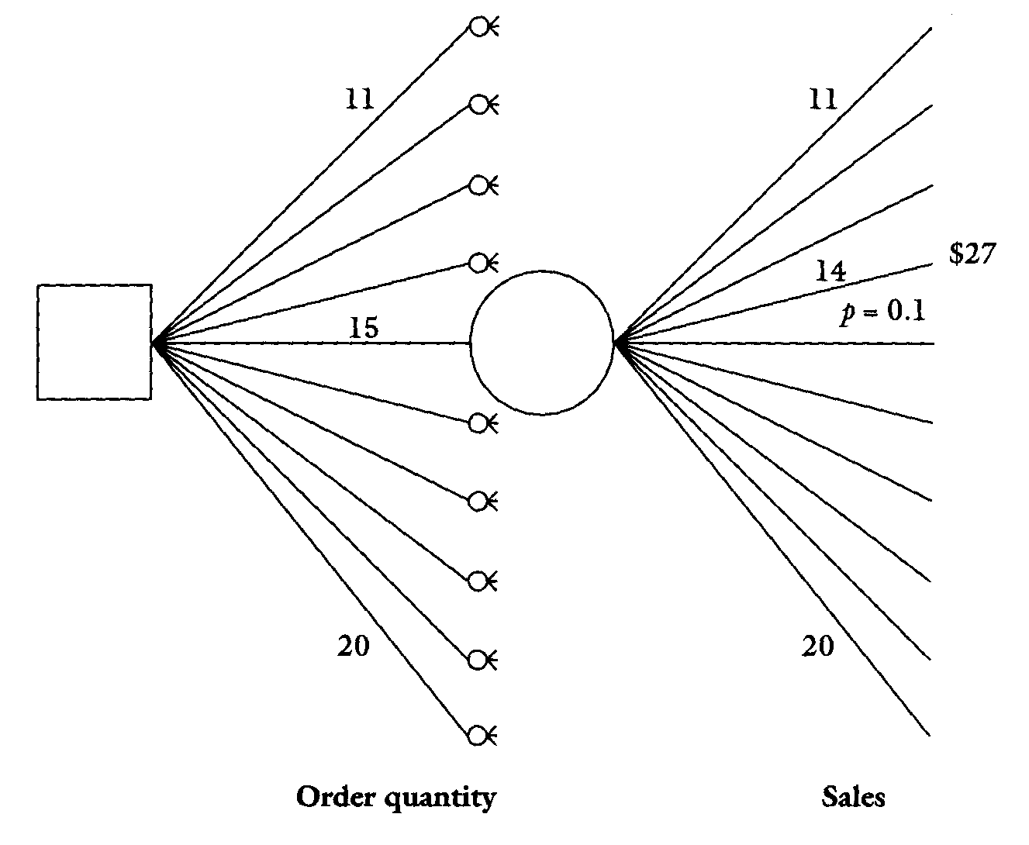
Each basket of strawberries sells for $6.00, the cost is $4.00, and the salvage value of any surplus sold to a cannery is $3.00. So, each unit sold brings a profit of $2.00, and each unit salvaged leads to a loss of $1.00. Before an economic analysis of the problem can be done, the uncertainty in number of baskets of strawberries must be dealt with.
Cora knows from past computer records that most daily sales are between 11 and 20 baskets, so she has 10 alternatives for the order quantity: 11, 12, . . . , 20. Exhibit 6.16 shows a part of a decision tree, which visually represents her choices and possible outcomes. Note that each of the 10 ordering quantities (Q) leads to 10 alternatives, so the tree has 100 terminal nodes. Suppose, for example, that Cora orders 15 baskets and the demand is 14. The supermarket sells 14 baskets and the profit is $14 x 2 = $28. There is one basket salvaged in the evening, bringing a loss of $1. Thus, the total conditional profit is $27. But what is the probability that the demand is 14 baskets?
Cora examines the past computer records, but the demand is too erratic to derive a sophisticated probability distribution. Moreover, the demand is seasonal, so her policy will be only for 3 months, when she will review the ordering policy again. And again, because costs, prices, and salvage values will change, she will have only an approximate answer anyway. To make things simple, she assumes a uniform distribution (each alternative has an equal probability of occurring) and sets the probability of each of the ten values equal to 0.1. So, the weighted

